

Western Australian Certificate of Education
ATAR course examination, 2019

Question/Answer Booklet

12 PHYSICS
Name

Evaluation - Gravitation

Student Number: In figures

Mark: $\frac{}{\text{2}\text{9}}$
In words

Time allowed for this paper
Reading time before commencing work: five minutes
Working time for paper: fifty minutes

Materials required/recommended for this paper

To be provided by the supervisor
This Question/Answer Booklet
Formulae and Data Booklet

To be provided by the candidate
Standard items: pens, (blue/black preferred), pencils (including coloured), sharpener, correction fluid/tape, eraser, ruler, highlighters
Special items: non-programmable calculators satisfying the conditions set by the School Curriculum and Standards Authority for this course

Important note to candidates
No other items may be taken into the examination room. It is your responsibility to ensure that you do not have any unauthorised notes or other items of a non-personal nature in the examination room. If you have any unauthorised material with you, hand it to the supervisor before reading any further.
The table below describes the orbital paths of a number of natural and man-made satellites orbiting the Earth.

Name | Mass (kg) | Orbital Radius  (x 10⁷ m) | Period (s) | Acceleration (ms⁻²) | $$\frac{\text{1}}{{\text{r}}^{\text{2}}}$$  (Units: )
Shuttle | 2.95 x 10⁴ | 0.671 | 5410
Tiros | 1405 | 0.722 | 6120
Itos | 340 | 0.787 | 6670
Lageos | 411 | 1.23 | 13500
Nato | 310 | 4.22 | 86400
Moon | 7.38 x 10²² | 38.2 | 2.42 x 10⁶

1. Using your knowledge of circular motion theory, show working to illustrate that the acceleration of each satellite is related to its orbital radius and its period by the expression:
$$\text{a =} \frac{\text{4}{\text{π}}^{\text{2}}\text{r}}{{\text{T}}^{\text{2}}}$$
(4 marks)

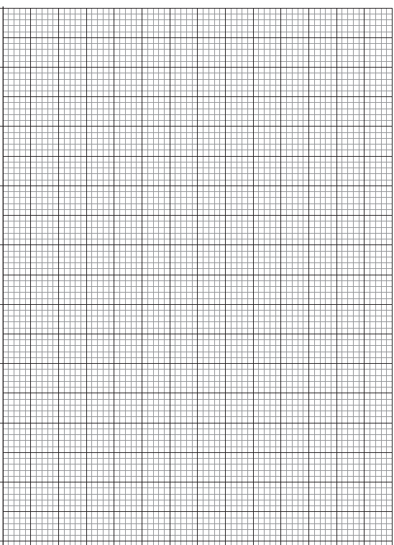

2. (a) Using the expression from Question 1, calculate and fill in the values for the fifth column in the table above. Ensure you display the values to the correct number of significant figures. (2 marks)

(b) Show workings for the calculation you performed to determine the acceleration of Tiros.
(1 mark)

3. (a) Fill in the values of uncertainty associated with Tiros in the table below. (4 marks)

Quantity |  | Absolute Uncertainty | Percentage Uncertainty (%)
Orbital Radius (x10⁷ m) | 0.722
Period (s) | 6120

(b) Using this information, calculate the percentage uncertainty (%) and absolute uncertainty for the acceleration of Tiros. (3 marks)

Ans: % Uncertainty acceleration: ____________________________
Ans: Absolute Uncertainty acceleration: _______________________
4. Complete the sixth column of the table on page 1 by calculating the values of inverse of radius squared. Clearly show the power of 10 and units by writing them at the top of that column.
(3 marks)

5. Plot a graph of gravitational field strength (g) against inverse of the radius squared (¹/_{r}²) on the grid on page 3. Include a line of best fit.
(A spare grid is on page 6.) (5 marks)

6. It is known that gravitational field strength due to the Earth can be calculated using the formula:
$$\text{g = }\frac{\text{G}{\text{M}}_{\text{E}}}{{\text{r}}^{\text{2}}}$$

Use your graph to determine the mass of the Earth. Show all working. (7 marks)

Spare grid



